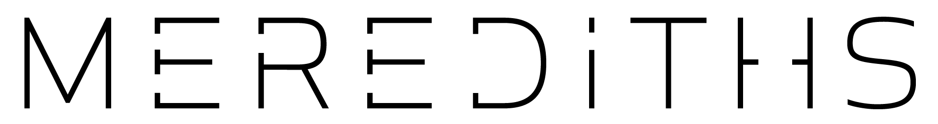

Merediths Cancellation Policy

Merediths is a small fine dining degustation only restaurant. We take great pride in preparing a memorable dining experience for you.
Since we often turn away reservation requests to hold your booking and planning for your degustation menu begins well in advance of your arrival, we ask that you kindly allow 48 hours notice for cancellations or to decrease the number in your party.
For these reasons, as well as past experiences, we ask that all overseas bookings and parties of 5 guests or more reserve by telephone with a credit card to secure their reservation. There will be no charge to your credit card unless the reservation is not cancelled or the party size decreased 48 hours prior to your reservation. In that case a cancellation fee will be incurred in the amount of the price of the desustation menu booked per person.
We make every effort to reconfirm all bookings several days prior by telephone. However, should we be unable to reach you, please call us on (09) 623 3140 to confirm your booking 24 hours prior to your reservation. We reserve the right to cancel unconfirmed bookings at our discretion.
Thank you for choosing Merediths for your dining experience. We look forward to hosting you soon!

